**FAST NATIONAL UNIVERSTIY OF COMPUTER AND EMERGING SCIENCES, PESHAWAR**

**DEPARTMENT OF COMPUTER SCIENCE**

**CL100 –Introduction to the information and communication technology LAB**



**Introduction to ICT**

**LAB MANUAL # 1**

**Instructor: Mazhar Iqbal**

**SEMESTER FALL 2023**

**Introduction to ICT**

Certainly, here's a concise overview of Information and Communication Technology (ICT):

* ICT stands for Information and Communication Technology.
* It encompasses technologies used for managing and processing information, as well as facilitating communication.
* Computing Devices: ICT includes computers, smartphones, tablets, and other devices used for processing and storing data.
* Networking: ICT involves the creation and management of networks that enable data and information exchange.
* Software: ICT covers a wide range of software applications used for various purposes, from word processing to data analysis (Word processing refers to the creation, editing, and formatting of textual content using software applications, like Microsoft Word or Google Docs.).
* Internet: ICT is closely linked to the internet, enabling global connectivity, communication, and access to information.
* Digital Communication: ICT enables instant communication through email, messaging apps, video conferencing, etc.
* Data Management: ICT includes methods for organizing, storing, and retrieving data efficiently.
* Multimedia: ICT supports the creation and manipulation of various media types, including images, audio, and video.
* E-Commerce: ICT facilitates online buying and selling of goods and services through platforms like e-commerce websites.
* Cybersecurity: ICT involves measures to protect digital systems, networks, and data from unauthorized access and attacks.
* Automation: ICT enables automation of tasks through programming and smart systems.
* Emerging Technologies: ICT encompasses emerging fields like artificial intelligence, virtual reality, and the Internet of Things (IoT).
* Remember that ICT is a broad and rapidly evolving field, continually shaping how we interact, communicate, and work in the digital age.Top of Form

**Components Of ICT:**

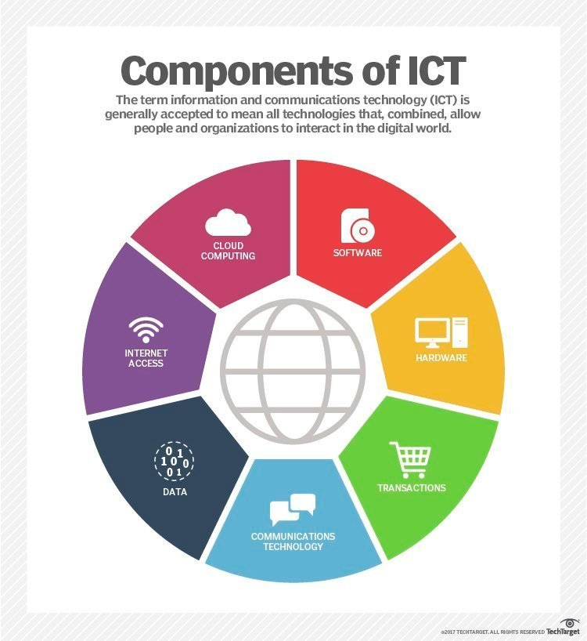

**COMPUTER:**

A **computer** is an electronic device that manipulates information, or data. It has the ability to **store**, **retrieve**, and **process** data. You may already know that you can use a computer to **type documents**, **send email**, **play games**, and **browse the Web**. You can also use it to edit or create **spreadsheets**, **presentations**, and even**videos**.

Before we talk about different types of computers, let's talk about two things all computers have in common: **hardware** and **software**.

* **Hardware** is any part of your computer that has a **physical structure**, such as the keyboard or mouse. It also includes all of the computer's internal parts, which you can see in the image below.

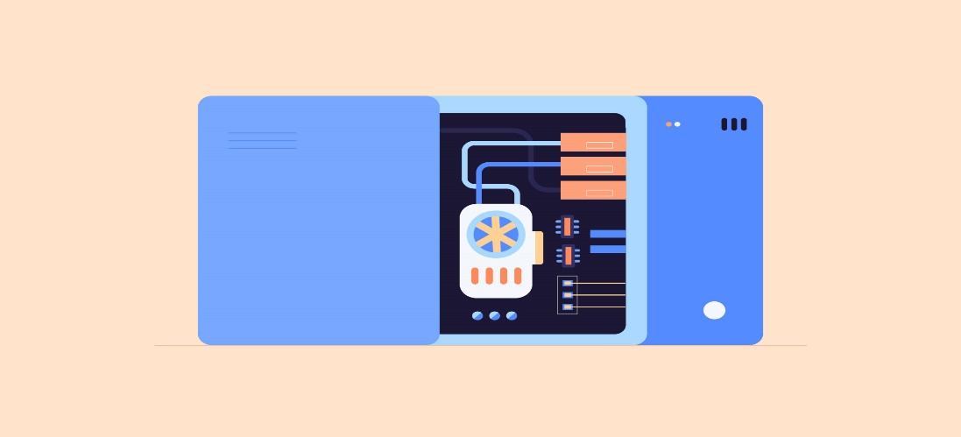

* **Software** is any **set of instructions** that tells the hardware **what to do** and **how to do it**. Examples of software include web browsers, games, mobile apps and word processors.



**Key Point:**

Everything you do on your computer will rely on both hardware and software.

**What are the different types of computers?**

When most people hear the word **computer**, they think of a **personal computer** such as a **desktop** or **laptop**. However, computers come in many shapes and sizes, and they perform many different functions in our daily lives. When you withdraw cash from an ATM, scan groceries at the store, or use a calculator, you're using a type of computer.



**Desktop Computer:**

Many people use **desktop computers** at work, home, and school. Desktop computers are designed to be placed on a desk, and they're typically made up of a few different parts, including the **computer case**, **monitor**, **keyboard**, and **mouse**.



**Laptop Computer:**

The second type of computer you may be familiar with is a **laptop computer**, commonly called a laptop. Laptops are battery-powered computers that are **more portable** than desktops, allowing you to use them almost anywhere.



**Tablet computers:**

**Tablet computers**—or **tablets**—are handheld computers that are even more portable than laptops. Instead of a keyboard and mouse, tablets use a **touch-sensitive screen** for typing and navigation. The **iPad** is an example of a tablet.



**Servers:**

A **server** is a computer that serves up information to other computers on a network. For example, whenever you use the Internet, you're looking at something that's stored on a server. Many businesses also use local **file servers** to store and share files internally.

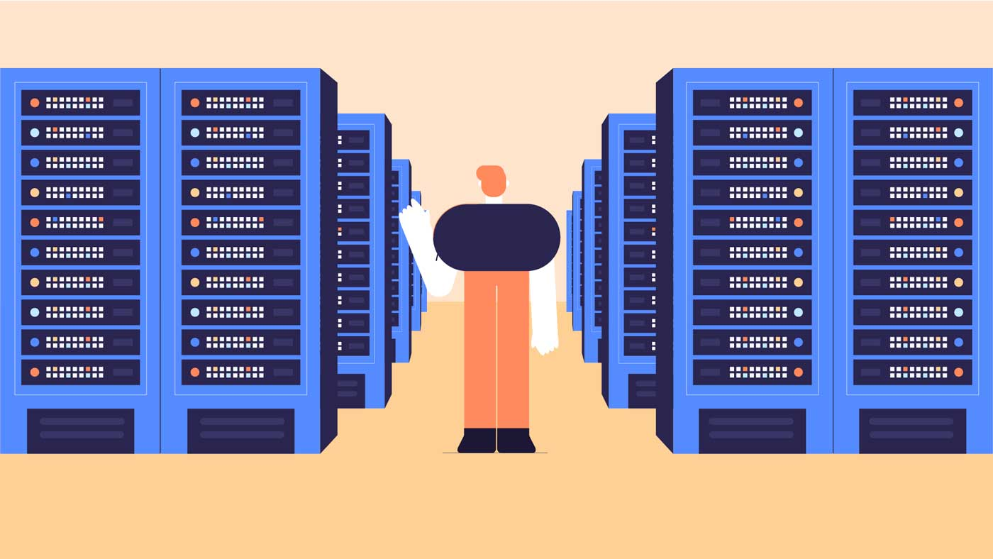

#### **Other types of computers:**

* Many of today's electronics are basically **specialized computers**, though we don't always think of them that way. Here are a few common examples.
* **Smartphones**: Many cell phones can do a lot of things computers can do, including browsing the Internet and playing games. They are often called **smartphones**.
* **Wearables**: Wearable technology is a general term for a group of devices—including**fitness trackers** and**smartwatches**—that are designed to be worn throughout the day. These devices are often called**wearables** for short.
* **Game consoles**:A **game console** is a specialized type of computer that is used for playing **video games** on your TV.
* **TVs**: Many TVs now include **applications**—or **apps**—that let you access various types of online content. For example, you can stream video from the Internet directly onto your TV.

# Experiment # 01

## Basic Mouse Functions

Point: Move the mouse until the pointer rests on what you want to open or use on the screen. The form of the mouse will change depending on what you are asking it to look at in Windows, so you need to be aware of what it looks like before you click.

Single**-**click: The **left mouse button** is used to indicate choices from menus and indicate choices of options within a “dialog box” while you are working in an application program. Roll the mouse pointer on top of the choice and press the left mouse button once.

Right-click**:** With a single quick press on the **right mouse button,** it will bring up a shortcut menu, which will contain specific options depending on where the right-click occurred.

Click and drag: This is used for a number of functions including choosing text to format, moving items around the screen, and choosing options from menu bars. Roll the mouse pointer over the item, click and hold down the left mouse button, and drag the mouse while still holding the button until you get to the desired position on the screen. Then release the mouse button.

Double-click: This is used to choose an application program. Roll the mouse pointer on top of the icon (picture on the desktop or within a window) of the application program you want to choose and press the left mouse button twice very rapidly. This should bring you to the window with the icons for that software package. Double-click on the icon with the name of the program.

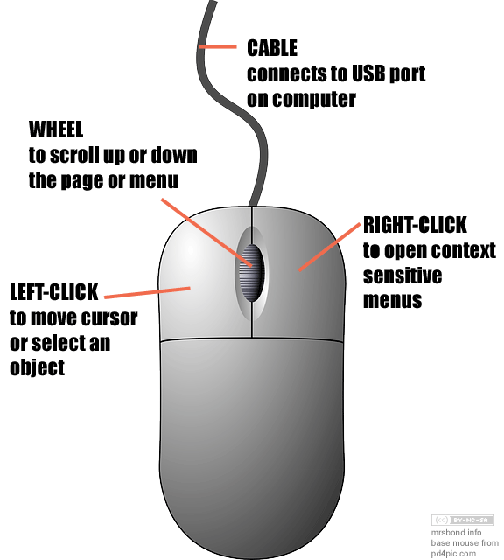

## Keyboard Shortcut

|  |  |
| --- | --- |
| Shortcut Keys | Description |
| [**Alt+F**](https://www.computerhope.com/jargon/a/alt-f.htm) | File menu options in current program. |
| [**Alt+E**](https://www.computerhope.com/jargon/a/alt-e.htm) | Open *Edit* options in current program. |
| [**Alt+Tab**](https://www.computerhope.com/jargon/a/alt-tab.htm) | Switch between open [programs](https://www.computerhope.com/jargon/p/program.htm). |
| [**F1**](https://www.computerhope.com/jargon/f/f1.htm) | View [help](https://www.computerhope.com/jargon/h/help.htm) information (F1 is used by almost every Windows program to display help). |
| [**F2**](https://www.computerhope.com/jargon/f/f2.htm) | [Rename](https://www.computerhope.com/jargon/r/rename.htm) a selected file. |
| [**F5**](https://www.computerhope.com/jargon/f/f5.htm) | [Refresh](https://www.computerhope.com/jargon/r/refresh.htm) the current program window. |
| [**Ctrl+D**](https://www.computerhope.com/jargon/c/ctrl-d.htm) | [Bookmarks](https://www.computerhope.com/jargon/b/bookmark.htm) the current page in most [Internet browsers](https://www.computerhope.com/jargon/b/browser.htm). |
| [**Ctrl+N**](https://www.computerhope.com/jargon/c/ctrl-n.htm) | Create a new or blank [document](https://www.computerhope.com/jargon/d/document.htm) in some software, or open a new [tab](https://www.computerhope.com/jargon/t/tab.htm) in most [Internet browsers](https://www.computerhope.com/jargon/b/browser.htm). |
| [**Ctrl+O**](https://www.computerhope.com/jargon/c/ctrl-o.htm) | [Open](https://www.computerhope.com/jargon/o/open.htm) a file in the current software. |
| [**Ctrl+A**](https://www.computerhope.com/jargon/c/ctrl-a.htm) | [Select all](https://www.computerhope.com/jargon/s/selectall.htm) text. |
| [**Ctrl+B**](https://www.computerhope.com/jargon/c/ctrl-b.htm) | Change selected text to be [bold](https://www.computerhope.com/jargon/b/bold.htm). |
| [**Ctrl+I**](https://www.computerhope.com/jargon/c/ctrl-i.htm) | Change selected text to be in [italics](https://www.computerhope.com/jargon/i/italic.htm). |
| [**Ctrl+U**](https://www.computerhope.com/jargon/c/ctrl-u.htm) | Change selected text to be [underlined](https://www.computerhope.com/jargon/u/underlin.htm). |
| [**Ctrl+F**](https://www.computerhope.com/jargon/c/ctrl-f.htm) | Open [find](https://www.computerhope.com/jargon/f/find.htm) window for current document or window. |
| [**Ctrl+S**](https://www.computerhope.com/jargon/c/ctrl-s.htm) | [Save](https://www.computerhope.com/jargon/s/save.htm) current document file. |
| [**Ctrl+X**](https://www.computerhope.com/jargon/c/ctrl-x.htm) | [Cut](https://www.computerhope.com/jargon/c/cut.htm) selected item. |
| **Shift+Del** | Cut selected item. |
| [**Ctrl+C**](https://www.computerhope.com/jargon/c/ctrlc.htm) | [Copy](https://www.computerhope.com/jargon/c/copy.htm) selected item. |
| [**Ctrl+Ins**](https://www.computerhope.com/jargon/c/ctrl-ins.htm) | Copy selected item |
| [**Ctrl+V**](https://www.computerhope.com/jargon/c/ctrl-v.htm) | [Paste](https://www.computerhope.com/jargon/p/paste.htm) |
| **Shift+Ins** | Paste |
| [**Ctrl+Y**](https://www.computerhope.com/jargon/c/ctrl-y.htm) | [Redo](https://www.computerhope.com/jargon/r/redo.htm) last action. |
| [**Ctrl+Z**](https://www.computerhope.com/jargon/c/ctrl-z.htm) | [Undo](https://www.computerhope.com/jargon/u/undo.htm) last action. |
| [**Ctrl+K**](https://www.computerhope.com/jargon/c/ctrl-k.htm) | Insert [hyperlink](https://www.computerhope.com/jargon/h/hyperlink.htm) for selected text. |
| [**Ctrl+P**](https://www.computerhope.com/jargon/c/ctrl-p.htm) | [Print](https://www.computerhope.com/jargon/p/print.htm) the current page or document. |
| [**Home**](https://www.computerhope.com/jargon/h/homekey.htm) | Goes to beginning of current [line](https://www.computerhope.com/jargon/l/line.htm). |
| [**Ctrl+Home**](https://www.computerhope.com/jargon/c/ctrl-home.htm) | Goes to beginning of document. |
| [**End**](https://www.computerhope.com/jargon/e/endkey.htm) | Goes to end of current line. |
| [**Ctrl+End**](https://www.computerhope.com/jargon/c/ctrl-end.htm) | Goes to end of document. |
| **Shift+Home** | [Highlights](https://www.computerhope.com/jargon/h/highligh.htm) from current position to beginning of line. |
| **Shift+End** | Highlights from current position to end of line. |
| **Ctrl+Left arrow** | Moves one [word](https://www.computerhope.com/jargon/w/word.htm) to the left at a time. |
| **Ctrl+Right arrow** | Moves one word to the right at a time. |
| [**Ctrl+Esc**](https://www.computerhope.com/jargon/c/ctrl-esc.htm) | Open the [Start menu](https://www.computerhope.com/jargon/s/startmen.htm). |
| [**Ctrl+Shift+Esc**](https://www.computerhope.com/jargon/c/ctrl-shift-esc.htm) | Open Windows [Task Manager](https://www.computerhope.com/jargon/t/taskmana.htm). |
| [**Alt+F4**](https://www.computerhope.com/jargon/a/alt-f4.htm) | Close the currently active program. |
| [**Alt+Enter**](https://www.computerhope.com/jargon/a/alt-enter.htm) | Open the [properties](https://www.computerhope.com/jargon/p/properti.htm) for the selected item (file, folder, shortcut, etc.). |

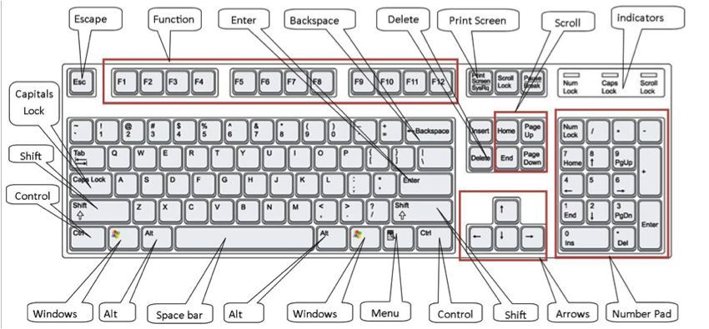

## The Desktop:

The desktop is the main screen area that you see after you turn on your computer and log on to Windows. Like the top of an actual desk, it serves as a surface for your work. When you open programs or folders, they appear on the desktop. You can also put things on the desktop, such as files and folders, and arrange them however you want.

The desktop is sometimes defined more broadly to include the taskbar and Windows Sidebar. The taskbar sits at the bottom of your screen. It shows you which programs are running and allows you to switch between them. It also contains the Start button , which you can use to access programs, folders, and computer settings. On the side of the screen, Sidebar contains small programs called gadgets.

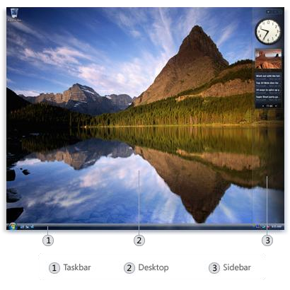

Working with desktop icons

Icons are small pictures that represent files, folders, programs, and other items. When you first start Windows, you'll see at least one icon on your desktop: the Recycle Bin (more on that later). Your computer manufacturer might have added other icons to the desktop. Some examples of desktop icons are shown below.

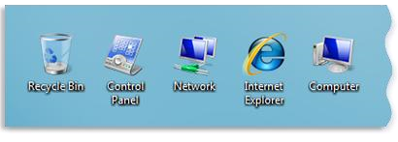

Examples of desktop icons

Double-clicking a desktop icon starts or opens the item it represents. For example, double-clicking the Internet Explorer icon starts Internet Explorer.

Adding and removing icons from the desktop

You can choose which icons appear on the desktop—you can add or remove an icon at any time. Some people like a clean, uncluttered desktop with few or no icons. Others place dozens of icons on their desktop to give them quick access to frequently used programs, files, and folders.

If you want easy access from the desktop to your favorite files or programs, create shortcuts to them. A shortcut is an icon that represents a link to an item, rather than the item itself. When you double-click a shortcut, the item opens. If you delete a shortcut, only the shortcut is removed, not the original item. You can identify shortcuts by the arrow on their icon.

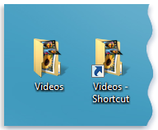

A folder icon (left) and a shortcut icon (right)

To add a shortcut to the desktop

1. Locate the item that you want to create a shortcut for (within Windows Explorer, or your Computer folder, for example).
2. Right-click the item, click Send To, and then click Desktop (create shortcut). The shortcut icon appears on your desktop.

To add or remove common desktop icons

### 

Common desktop icons include Computer, your personal folder, Network, the Recycle Bin, Internet Explorer, and Control Panel.

1. Right-click an empty area of the desktop, and then click Personalize.
2. In the left pane, click Change desktop icons.
3. Under Desktop icons, select the check box for each icon that you want to add to the desktop, or clear the check box for each icon that you want to remove from the desktop, and then click OK.

To move a file from a folder to the desktop

1. Open the folder that contains the file.
2. [Drag](mshelp://windows/?id=a02f310e-c1c4-4bc9-8706-4d0aadd51b6d#gtmt_gls_drag_def) the file to the desktop.

To remove an icon from the desktop

• Right-click the icon, and then click Delete. If the icon is a shortcut, only the shortcut is removed; the original item is not deleted.

Moving icons around

Windows stacks icons in columns on the left side of the desktop. But you're not stuck with that arrangement. You can move an icon by dragging it to a new place on the desktop.

You can also have Windows automatically arrange your icons. Right-click an empty area of the desktop, click View, and then click Auto Arrange. Windows stacks your icons in the upper-left corner and locks them in place. To unlock the icons so that you can move them again, click Auto Arrange again, clearing the check mark next to it.

**Note:** By default, Windows spaces icons evenly on an invisible grid. To place icons closer together or with more precision, turn off the grid. Right-click an empty area of the desktop, click View, and then click Align to Grid to clear the check mark. Repeat these steps to turn the grid back on.

Selecting multiple icons

To move or delete a bunch of icons at once, you must first select all of them. Click an empty area of the desktop and drag the mouse. Surround the icons that you want to select with the rectangle that appears. Then release the mouse button. Now you can drag the icons as a group or delete them.

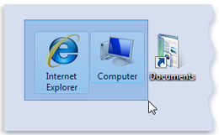

Select multiple desktop icons by dragging a rectangle around them.

Hiding desktop icons

If you want to temporarily hide all of your desktop icons without actually removing them, right-click an empty part of the desktop, click View, and then click Show Desktop Icons to clear the check mark from that option. Now no icons are displayed on the desktop. You can get them back by clicking Show Desktop Icons again.

## The Recycle Bin

When you delete a file or folder, it doesn't actually get deleted right away—it goes to the Recycle Bin. That's a good thing, because if you ever change your mind and decide you need a deleted file, you can get it back.

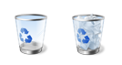

The Recycle Bin when empty (left) and full (right)

If you're sure that you won't need the deleted items again, you can empty the Recycle Bin. Doing that will permanently delete the items and reclaim any disk space they were using.

Picking a desktop background

One of the easiest ways to personalize your computer is to change the desktop background, also called the wallpaper. You can choose one of the backgrounds provided with Windows, pick a favorite digital picture from your own collection, or use a solid background color. You can also find pictures on the Internet designed to be used as desktop backgrounds.

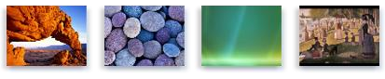

Sample desktop backgrounds provided with Windows

To change the desktop background

1. Right-click on your desktop and choose Personalize.
2. Click the Desktop Background link.
3. Click the picture or color you want for your desktop background.

If the picture you want to use is not in the list of desktop background pictures, click Browse to search for the picture on your computer. When you find the picture you want, double-click it. It will become your desktop background and appear in the list of desktop backgrounds.

1. Under How should the picture be positioned, choose to have the picture fit the screen, tile, or be centered on the screen, and then click OK.

**Note:** If you choose to have a centered picture as your desktop background, you can also have a color background to frame your picture. Under How should the picture be positioned, click Change background color, click a color, and then click OK.

Tip

• You can make any picture on your computer your desktop background by right clicking the picture, and then clicking Set as Desktop Background.

To change the theme to Windows Classic

1. Right-click on your desktop and choose Personalize.
2. Under Theme, select the Windows Classic theme in the drop-down list, and then click OK.

## E-Mail Address

To send or receive an email, you must have an email address. This address is unique in nature and it has two important parts. The first part is the ‘user name’ and the other is the ‘domain name’. These two are separated by a special symbol @. The domain name can be same for lots of people. For example cmfri@gmail.com and cmfri1@gmail.com are two addresses with the same domain name gmail.com. But the user names cmfri and cmfri1 are different and hence the addresses are different.

Creating an E-Mail Account

Email, short for Electronic Mail, is a component of internet. It is a fast and economic way of sending messages to individuals and groups of people. Messages can include text, pictures or animations.

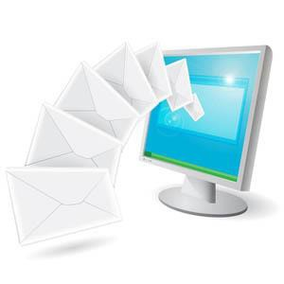

This section discusses on creation and accession of an email account, opening and reading of received mails and composing and sending mails. Several sites on the internet allow you to create an email account and send and receive email and attachments for free, for example gmail.com, hotmail.com, rediff.com, yahoo.com. This session focus on the services available through Gmail as it is free and is the most popular email service available today.